Example of Produced summaries, tables and figures

### 6.1.2 Basalt Hills

The Basalt Hills stratum occupies approximately 112,532 acres of land within the SLVFO. The BH ESs included 31 Basalt Hill 7-12" (R051XY277CO), 1 Basalt Hills (R048AY277CO) and 7 Basalt Hills (R048AY277CO). Site characteristics varied from their ESs in multiple areas including percent clay (15 plots), percent slope (4 plots), percent rock fragment (18 plots), soil texture (4 plots), landscape type (16 plots), elevation (1 plot), rock fragment type (3 plots) and depth to bedrock (2 plots). Annual precipitation ranged from 7-30.3 inches with a mean of 11.23 inches. Slope ranged from 1.19-58% with a mean of 16.27%. Elevation ranged from 2,285-2,769 feet with a mean of 2,501 feet. Landscape type was predominantly Hills/Mountains (27 plots) followed by Fan Piedmont (10 plots) and Terraces (2 plots). The most common soil textures included loam (36 horizons), sandy loam (24 horizons) and clay loam (14 horizons). Rock fragments ranged from 0-90% with a mean of 29.45%. Effervescence ranged from non-effervescent to violently effervescent, violently being most common. Percent clay ranged from 1-60% with a mean of 17.76%. BOGR2, HECO26, KRLA2, PIED, ELEL5 and CHGR6 were common species for the BH stratum.

#### 6.1.2.1 Soil Stability

Soil stability had an average of 3.36 for all samples with a difference of more than 1 between samples under and not under cover (Table 7).

Table 7. Summary of soil stability test results in the BH stratum.

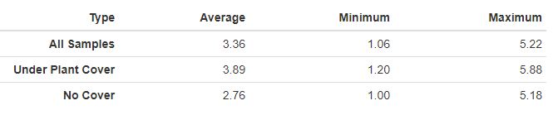

#### 6.1.2.2 Vegetation and Surface Cover

Grass and rock covers were the most dominant cover type in the BH stratum (see Figure 4). Graminoid species BOGR2 dominated the stratum (Figure 5 and Table 8). The BH stratum didn’t have any noxious or grass species present (Figure 2, Figure 3). Mean foliar cover was highest in this stratum (Figure 4). There were no browse species in the BH stratum.

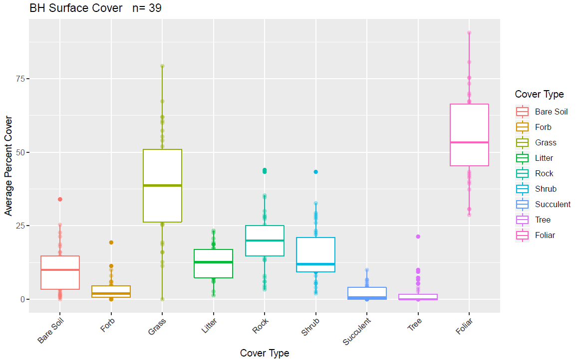

Figure 4. Surface and vegetation cover using line-point intercept results for the BH stratum. n=population size.

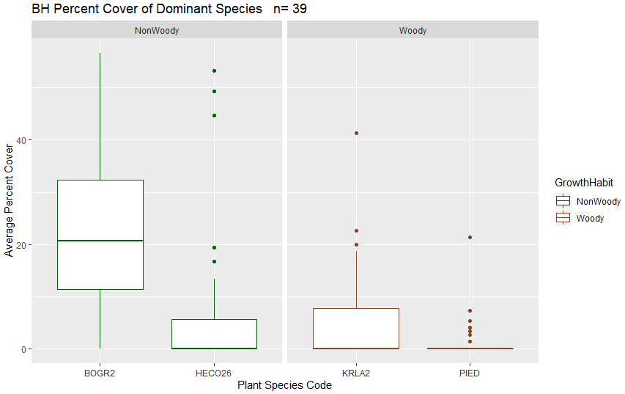

Figure 5. Dominant species categorized by growth form (grass, woody, herbaceous and/or noxious) in the MC stratum based on LPI results. n=population size.

#### 6.1.2.3 Canopy Gap

Percent canopy gap ranged from 13.12-31.93%. Percent canopy cover ranged from 29.03-86.88%. The average percent of canopy gaps per plot was 41.48% and the average canopy cover was 58.52%.

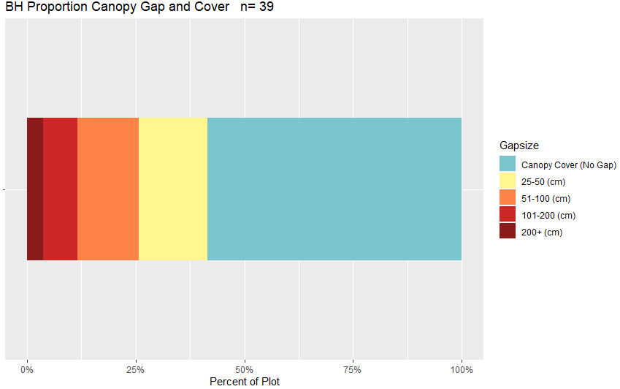

Figure . Barchart of canopy cover and canopy gaps for the BH stratum based on Gap Intercept results. Canopy cover was determined by subtracting the percent canopy gaps from 100. n=population size.

Table 8. Surface indicators, vegetation cover, canopy gap and cover, and species richness values determined using LPI for the MC stratum. Percent values are the average percent hit.

|  |  |  |  |  |
| --- | --- | --- | --- | --- |
| **Indicator** | **Average** | **Minimum** | **Maximum** | **St.Dev.** |
| **Surface Indicator (%)** | | |  |  |
| Rock Fragment | 19.98 | 3.33 | 44 | 9.89 |
| Litter | 12.53 | 1.33 | 23.33 | 5.54 |
| Bare Soil | 10.56 | 0 | 34 | 8.67 |
| **Foliar Cover (%)** | |  |  |  |
| Shrub/Sub-shrub | 15.09 | 2 | 43.33 | 9.25 |
| Grass | 38.48 | 0 | 79.33 | 17.57 |
| Succulent | 2.03 | 0 | 10 | 2.5 |
| Tree | 1.95 | 0 | 21.33 | 4.24 |
| Noxious Forb/Herb | 0 | 0 | 0 | 0 |
| Nonnoxious Forb/Herb | 3.23 | 0 | 20.67 | 3.97 |
| **Vegetation Height (cm)** | | |  |  |
| Grass | 26.86 | 6 | 48.07 | 9.94 |
| Forb/Herb | N/A | N/A | N/A | N/A |
| Tree | 224.93 | 25 | 610 | 127.91 |
| Shrub | 26.48 | 26.48 | 26.48 | 26.48 |
| **Dominant Grass Cover (%)** | | |  |  |
| BOGR2 | 0.46 | 0 | 1 | 0.5 |
| HECO26 | 0.21 | 0 | 1 | 0.41 |
| **Dominant Herb. Cover (%)** | | |  |  |
| N/A | N/A | N/A | N/A | N/A |
| **Dominant Woody Cover (%)** | | |  |  |
| KRLA2 | 0.21 | 0 | 1 | 1 |
| PIED | 0.11 | 0 | 1 | 1 |
| **Canopy Gaps (%)** | |  |  |  |
| Gaps 25-50 cm | 15.81 | 1.39 | 25.39 | 5.24 |
| Gaps 51-100 cm | 14.07 | 3.13 | 27.16 | 6.57 |
| Gaps 101-200 cm | 7.94 | 0 | 22.28 | 6.01 |
| Gaps >200 cm | 3.66 | 0 | 42.95 | 7.45 |
| **Canopy Cover (%)** | |  |  |  |
| Total Canopy Cover | 58.52 | 29.03 | 86.88 | 14.47 |
| **Species Richness** | |  |  |  |
| No. Species per Plot | 25 | 2 | 53 | 10.83 |

MMS mean foliar cover was the second highest of all stratum (Figure 2). All plots had less than 15 shrubs of each age class (Figure 5). ARNO4 and ARTRW8 had higher shrub density then other browse species (Figure 11).

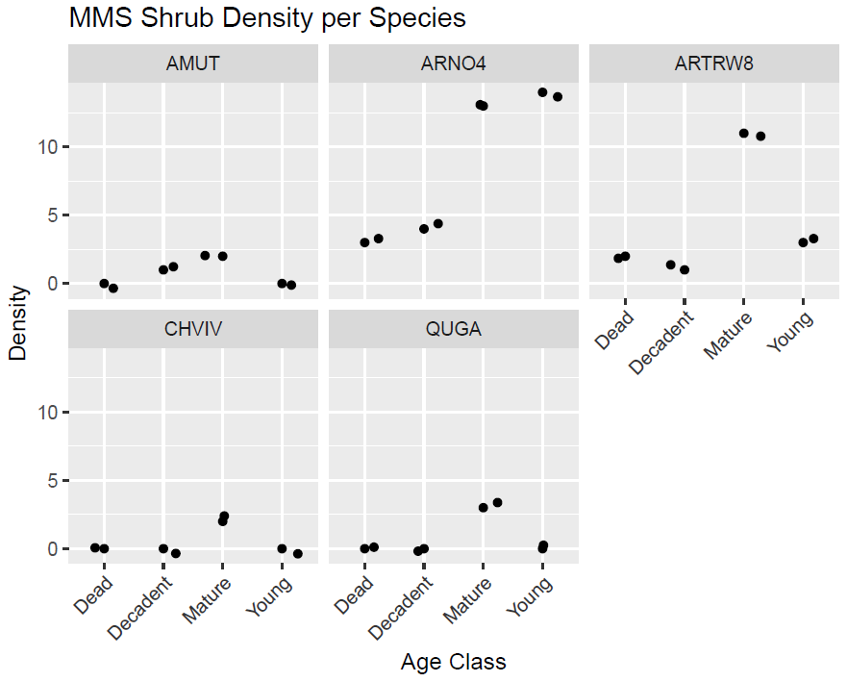

Figure 11. Shrub density for the MMS stratum categorized by species based on the browse study results.

TerrADat Query Results were used in the comparison of actual values (calculations for each category outlined in section 6.1.1) to benchmark values. A buffer of ± 2 was used for all benchmark values unless the value was 2 then a buffer of ± 1 was used. If the value was 1 then no buffer was used. No upper limit was used for Percent Nonnoxious Species. For UFO, SS Forb Height was not changed due to the already low benchmark. Number of Forbs and Shrub Density benchmarks did not have a buffer due to a need for strict meeting or not meeting criteria. Intensification benchmarks were set for ESD not strata.

The master sample project had three strata (PJ, MMS and MC) that met at least 40% of their benchmarks. SD and SS strata met 30% and ~38% of their benchmarks respectively (Table 35). The intensification project had 4 ESDs (SF, SSD, DSJ, LF) that met 40-50% of their benchmarks. The CSD ESD only met ~11% of the expected benchmarks (Table 36). LF only had one sample and therefore either met (100%) or did not meet (0%) the criteria.

Table 35. Percent of master sample sites meeting the sampled stratum benchmarks.

|  |  |  |
| --- | --- | --- |
| **Strata** | **Benchmark Category** | **% Meeting Benchmark** |
| *SD* | Percent Bare Ground (10-40%) | 72.22% |
|  | Soil Aggregate Stability (>3) | 61.11% |
|  | Litter (5-20%) | 27.78% |
|  | Native (nonnoxious) Species (≥20%) | 77.78% |
|  | Percent Grass Cover (5-15%) | 55.56% |
|  | Percent Forb Cover (5-10%) | 16.67% |
|  | Percent Shrub Cover (10-35%) | 27.78% |
|  | Percent Nonnative (noxious) Species (≤15) | 100.00% |
|  | Number of Forbs (>5) | 27.78% |
|  | Shrub Density (≥0.25 shrub/m^2) | 62.50% |
| *SS* | Percent Bare Ground (10-35%) | 66.67% |
|  | Soil Aggregate Stability (≥4) | 11.11% |
|  | Litter (10-40%) | 66.67% |
|  | Percent Grass Cover (>10%) | 55.56% |
|  | Percent Forb Cover (5-40%) | 11.11% |
|  | Percent Sage Cover (5-25%) | 66.67% |
|  | Percent Other Shrub Cover (5-15%) | 44.44% |
|  | Percent Tree Cover (<3%) | 77.78% |
|  | Grass Height (>10 cm) | 100% |
|  | Forb Height (>3 cm) | 100% |
|  | Sage Height (25-56 cm) | 75% |
|  | Percent Nonnative (noxious) Species (≤10) | 100.00% |
|  | Number of Forbs (>5) | 33.33% |
| *PJ* | Percent Bare Ground (0-35%) | 100% |
|  | Soil Aggregate Stability (>3) | 76.92% |
|  | Litter (20-60%) | 78.57% |
|  | Percent Grass Cover (2-15%) | 21.43% |
|  | Percent Forb Cover (2-5%) | 50% |
|  | Percent Shrub Cover (3-40%) | 64% |
|  | Percent Tree Cover (15-80%) | 71% |
|  | Percent Nonnative (noxious) Species (≤15) | 100% |
|  | Number of Forbs (>5) | 79% |
| **Strata** | **Benchmark Category** | **% Meeting Benchmark** |
| *MMS* | Soil Aggregate Stability (≥5) | 44.44% |
|  | Percent Nonnative (noxious) Species (≤5) | 100% |
|  | Number of Forbs (>5) | 100% |
| *MC* | Number of Forbs (>5) | 100% |
|  |  |  |
|  |  |  |

